Cloud Computing

Submitted By: Zunaira Khatoon
Submitted To: Engr. Shoaib
Roll No: BSE-2023-074
Section: V-B
LAB 4

Task 1 – Verify VM resources in VMware
Step1
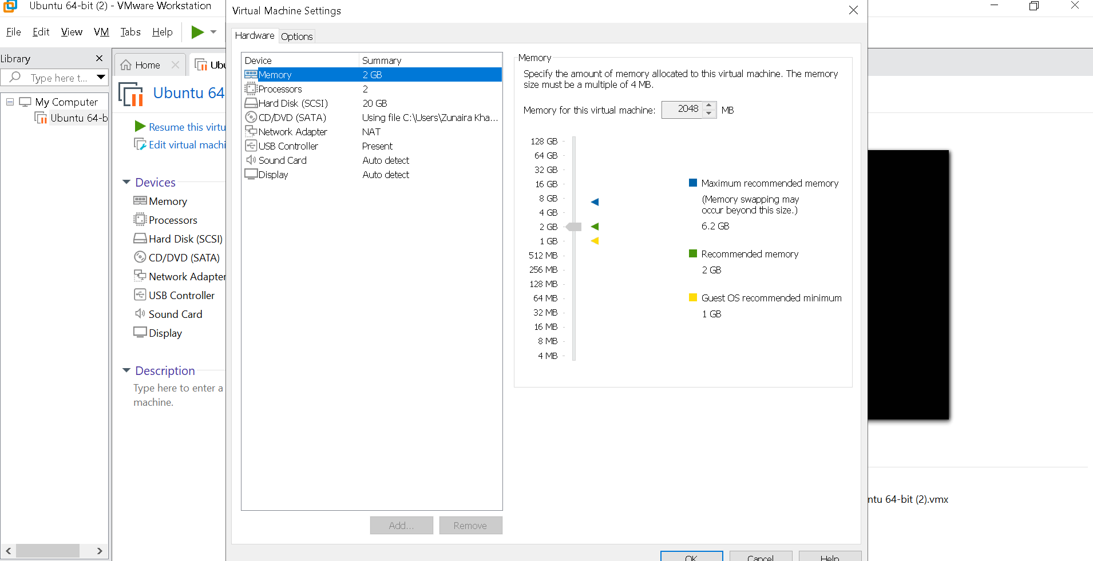
Task 2 – Start VM and log in (use your preferred host terminal method only)
Step1
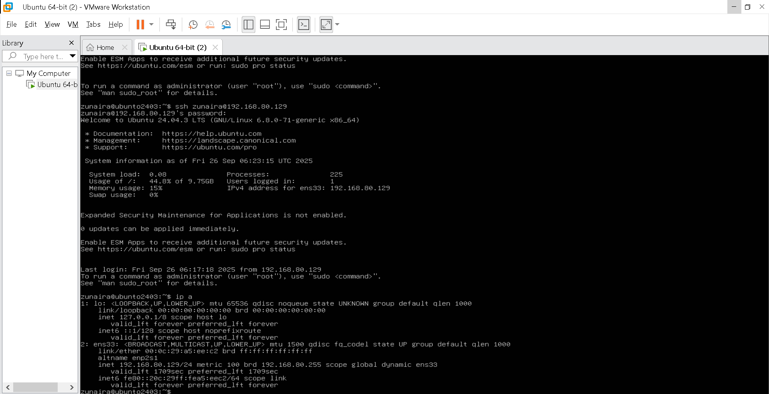
Step2
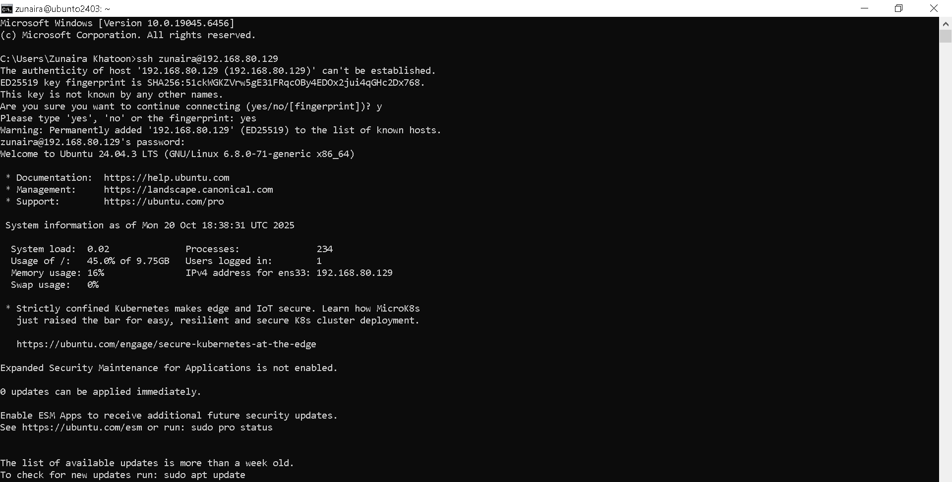
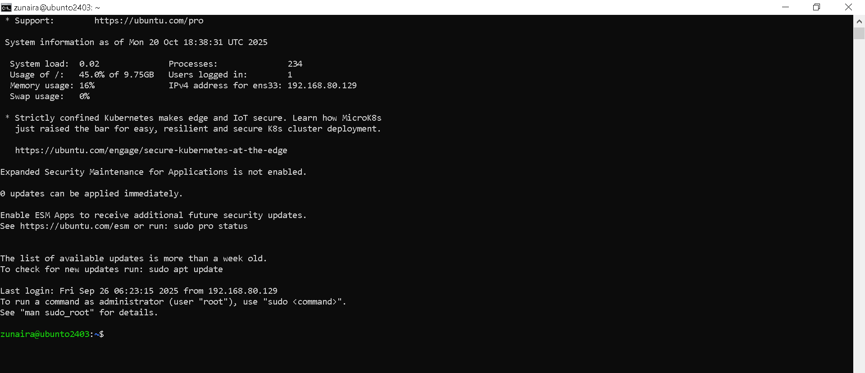
Step3
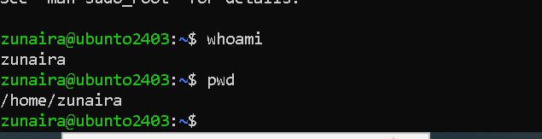
Task 3 – Filesystem exploration — root tree and dotfiles
Step1
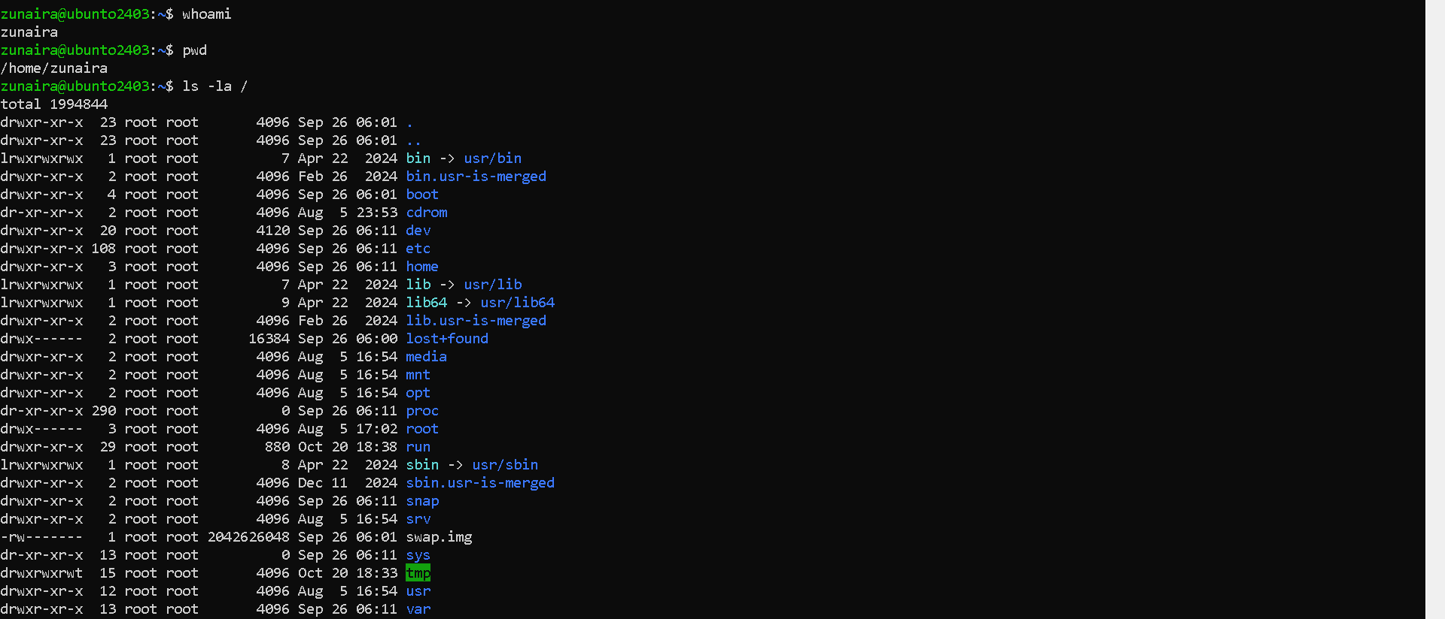
Step2
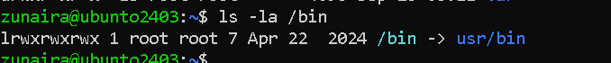
Step3
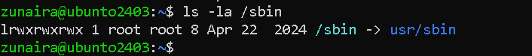
Step4
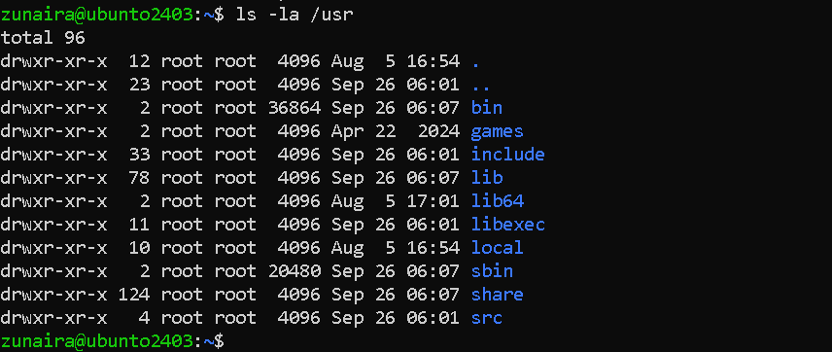
Step5
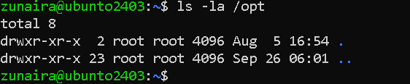
Step6
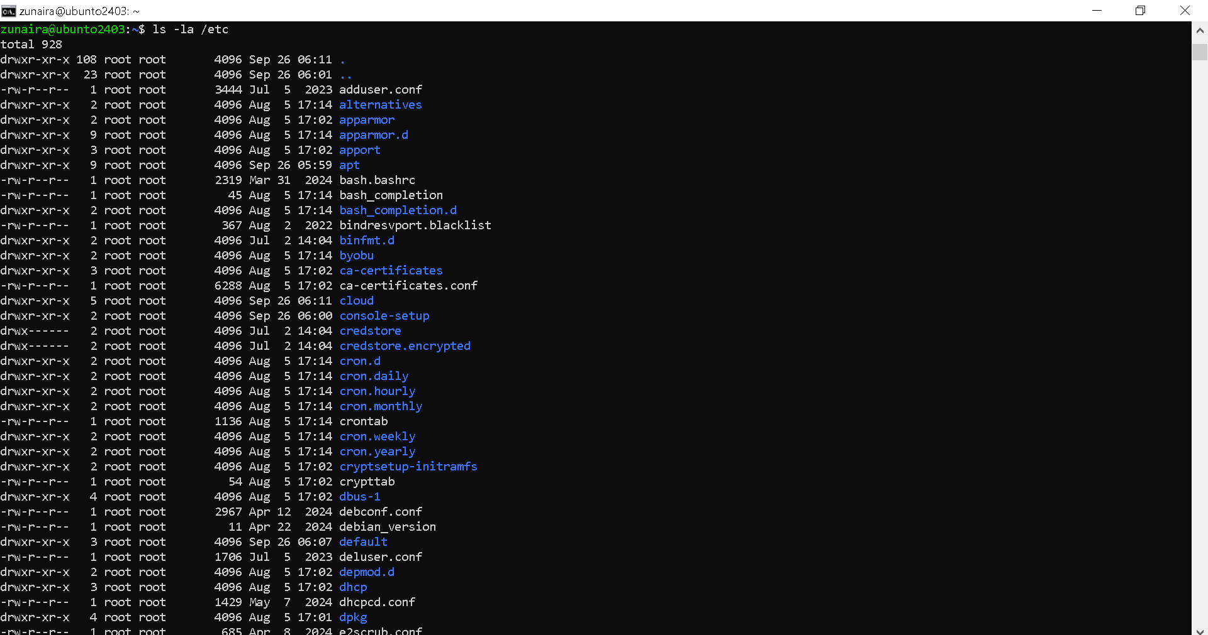
Step7
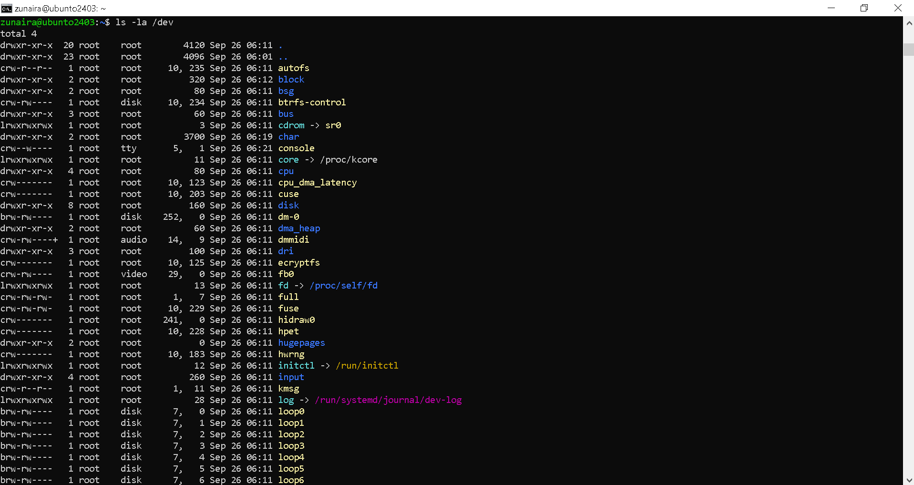
Step8
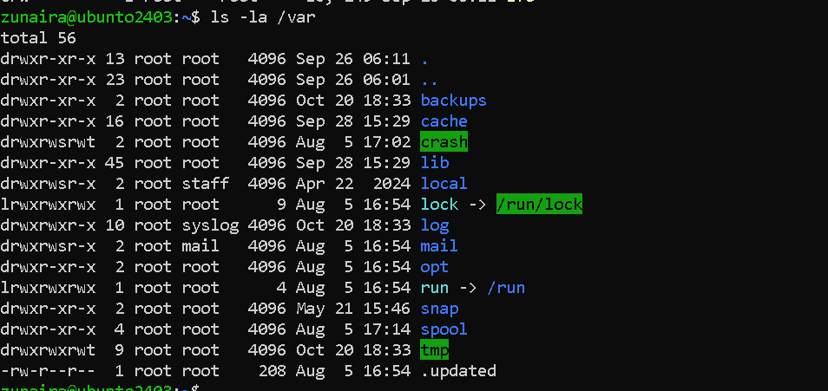
Step9
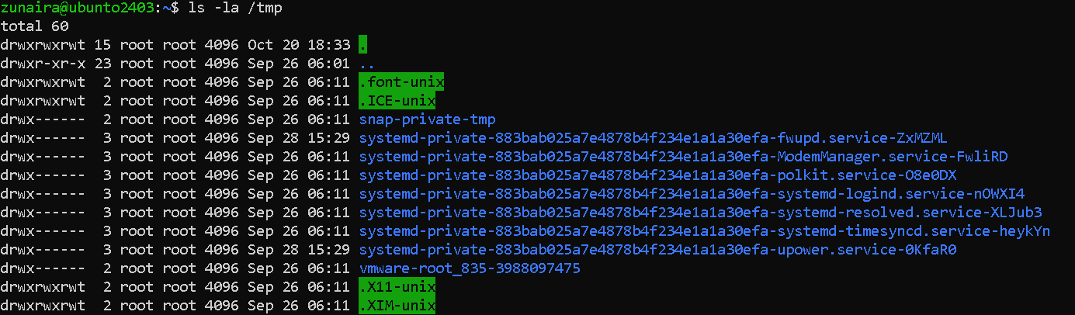
Step 10
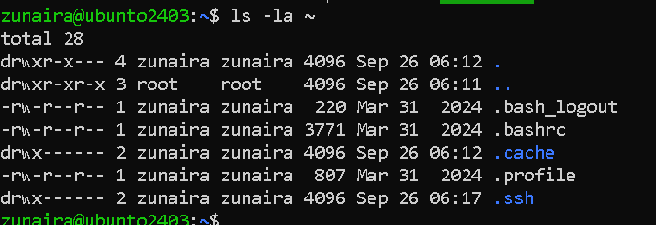
Step 11
Task 4 – Essential CLI tasks — navigation and file operations
Step1
Step2
Step3
Step4
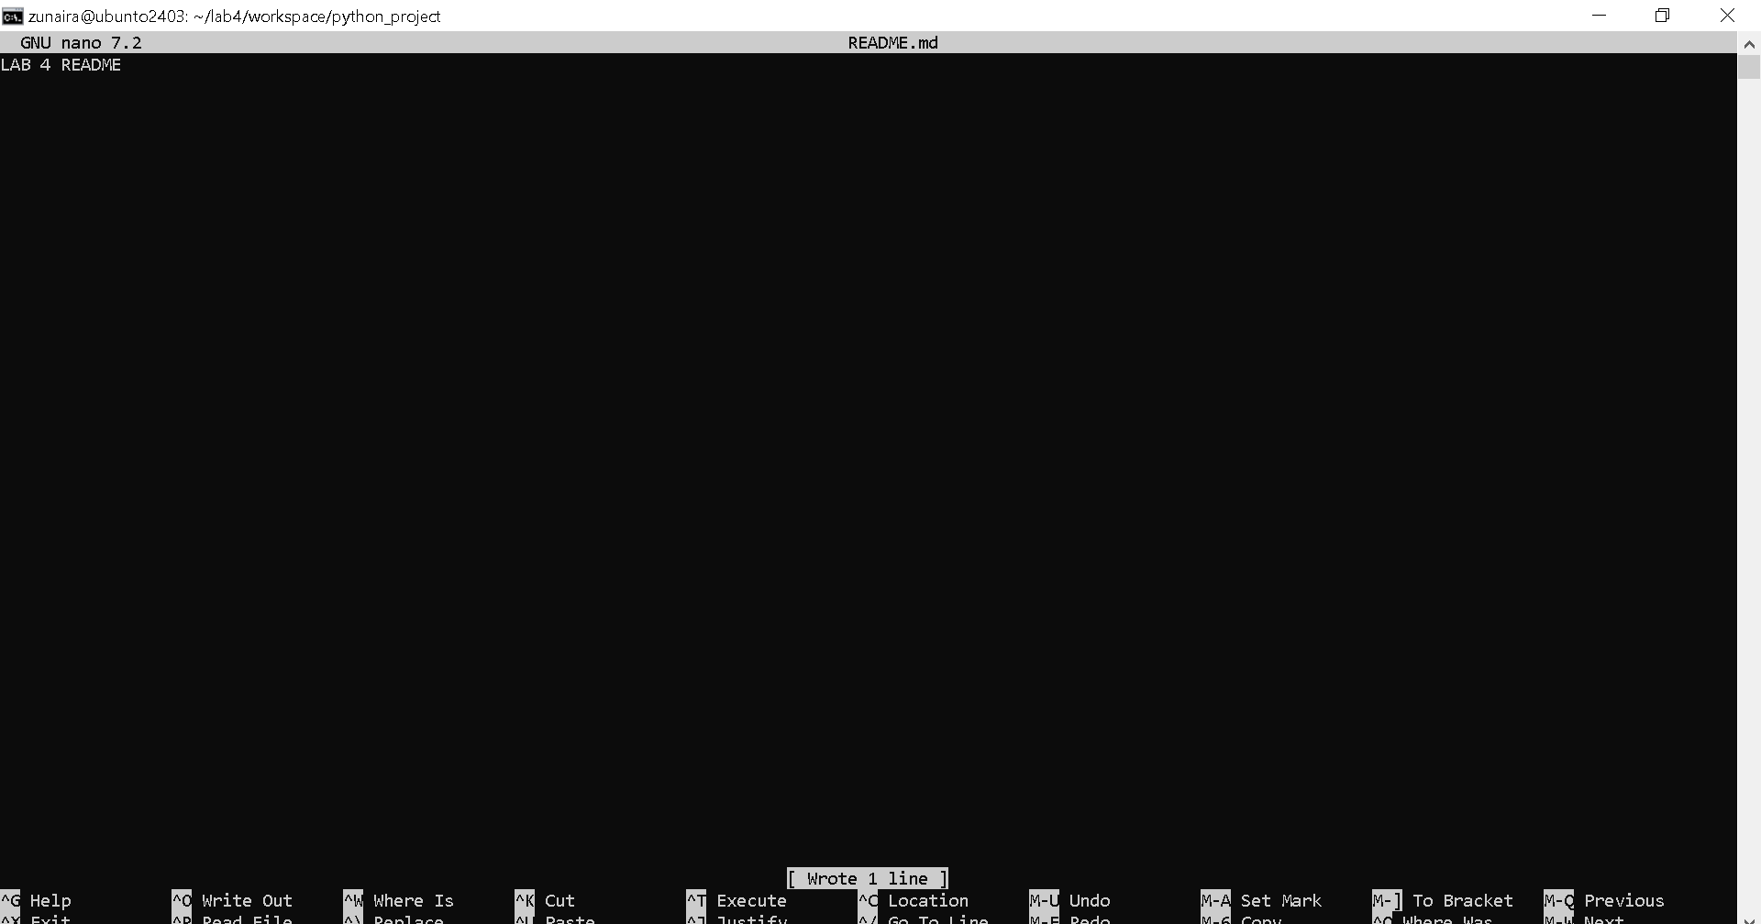
Step5
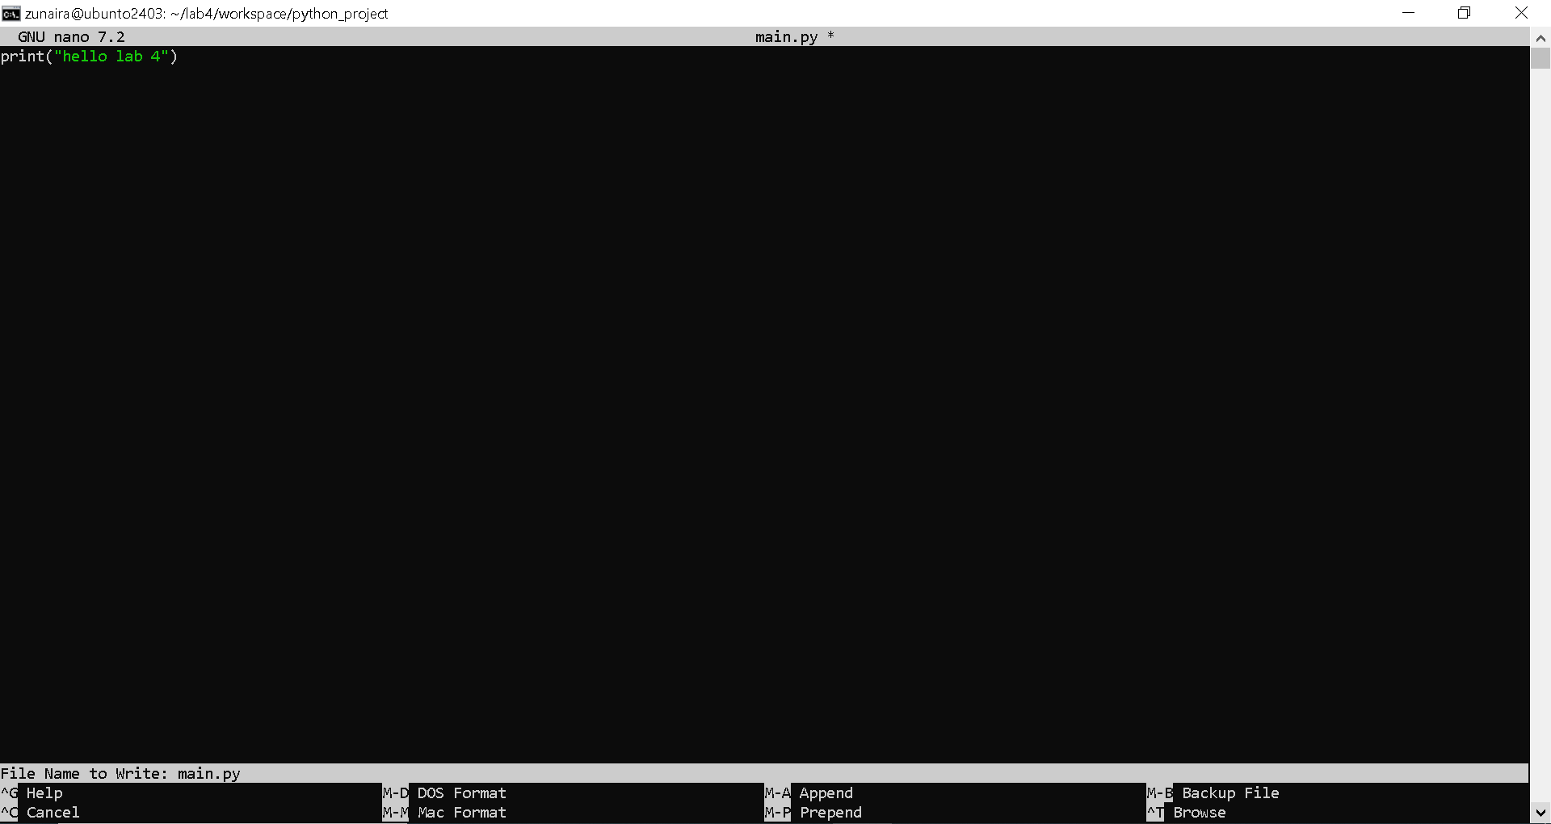
Step6
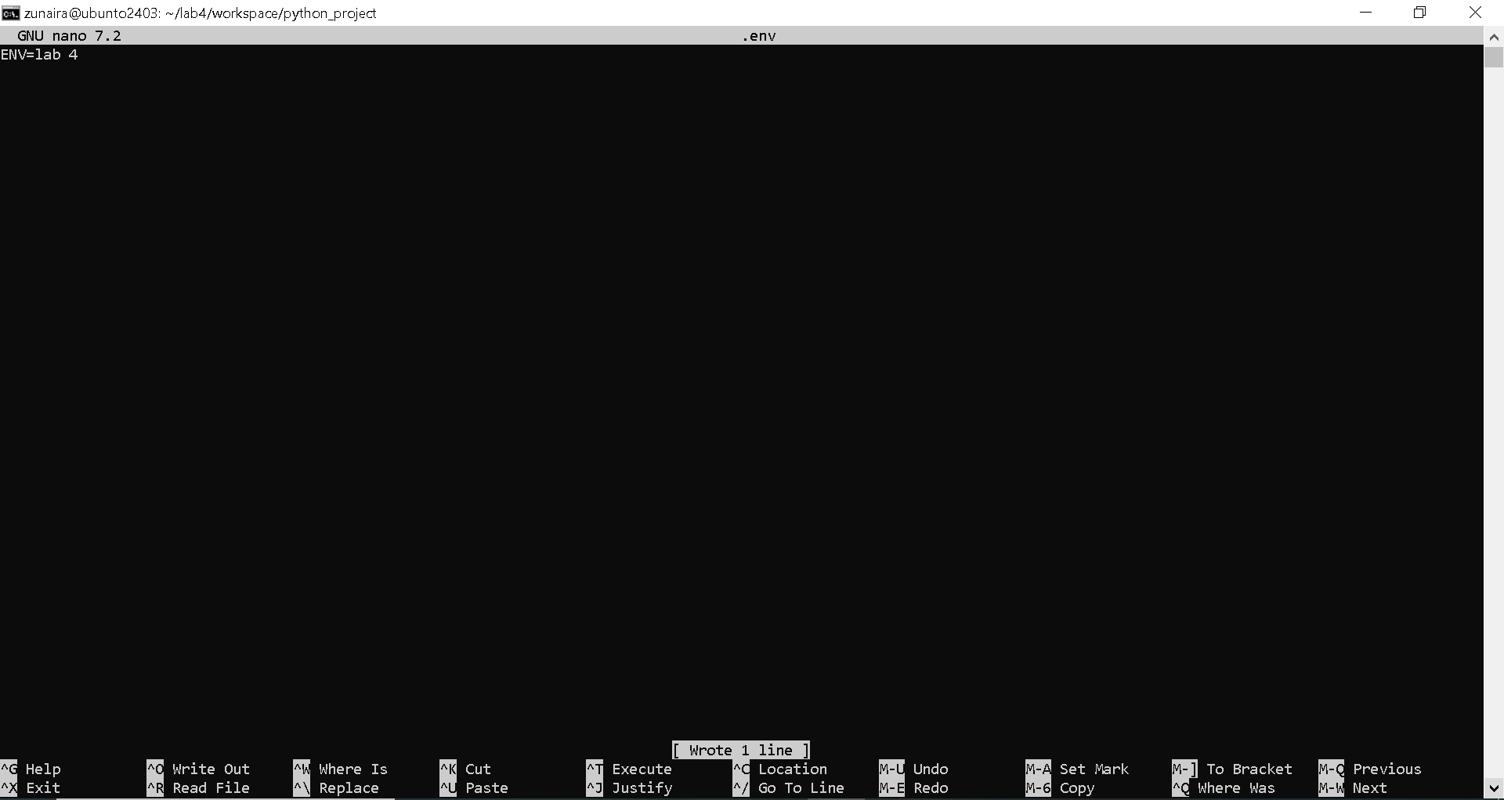
Step7
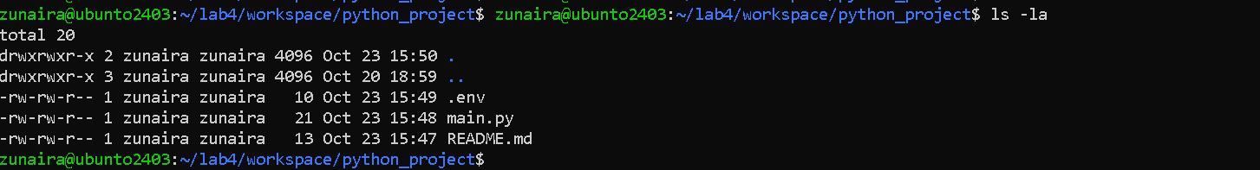
Step8
Step9
Step 10
Step 11
Step 12
Step 13
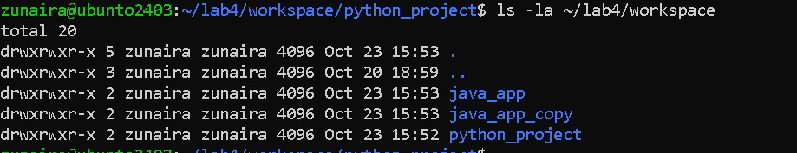
Step 14
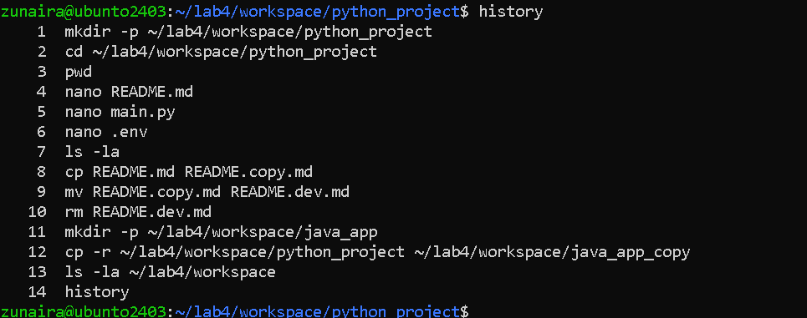
Task 5 – System info, resources & processes
Step1
Step2
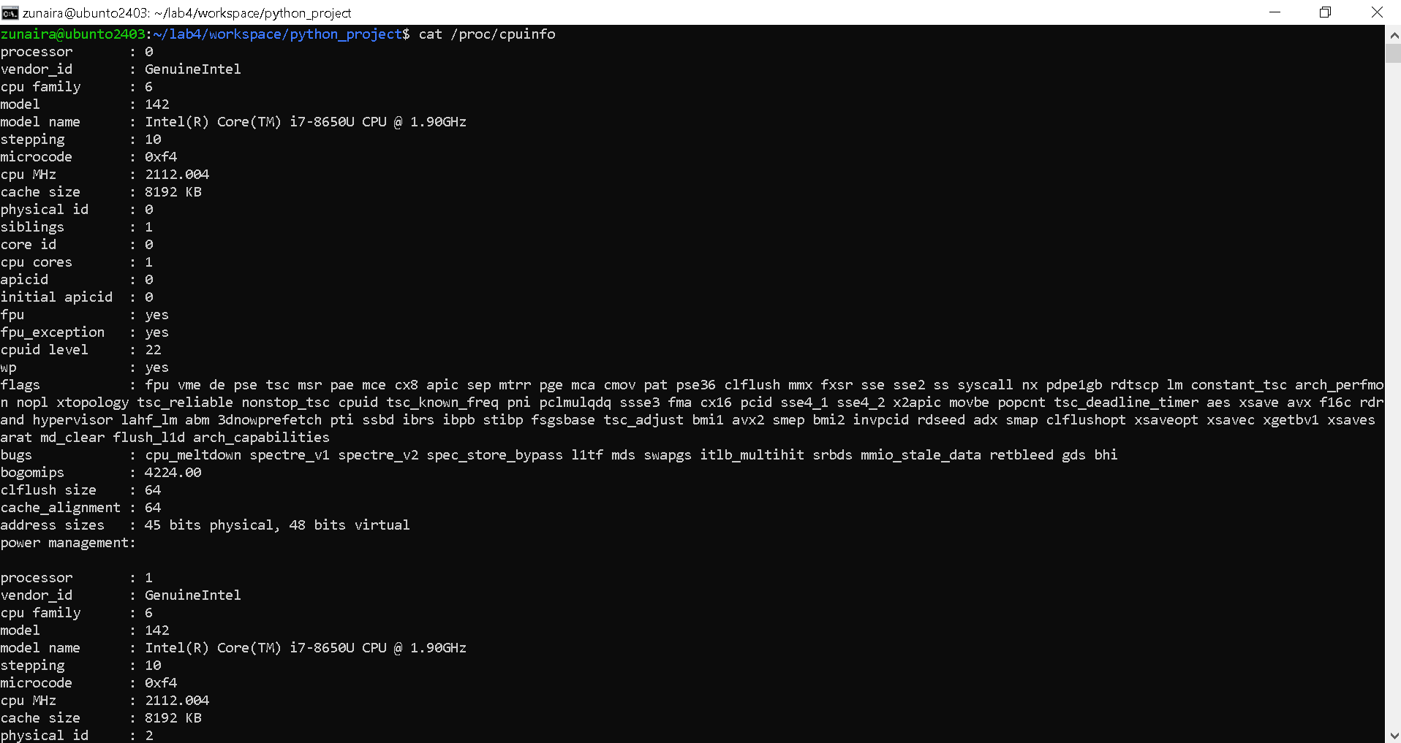
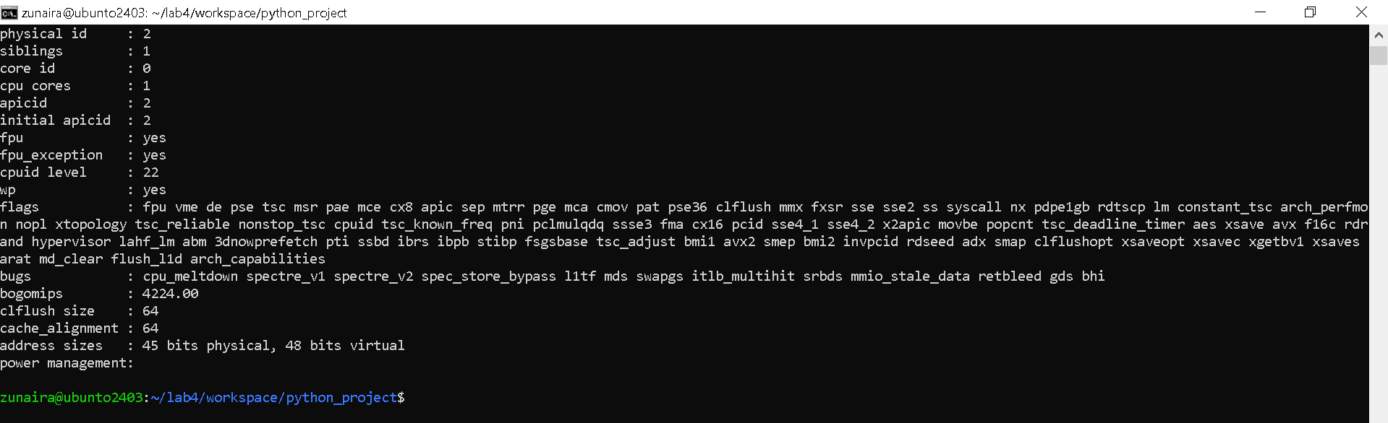
Step3
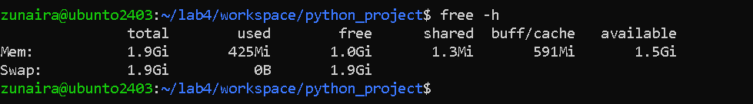
Step4
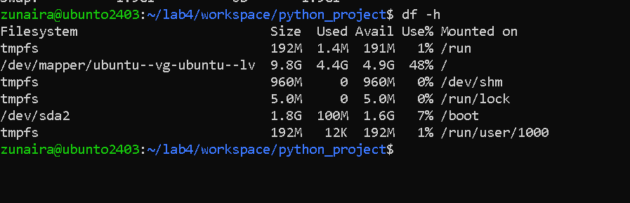
Step5
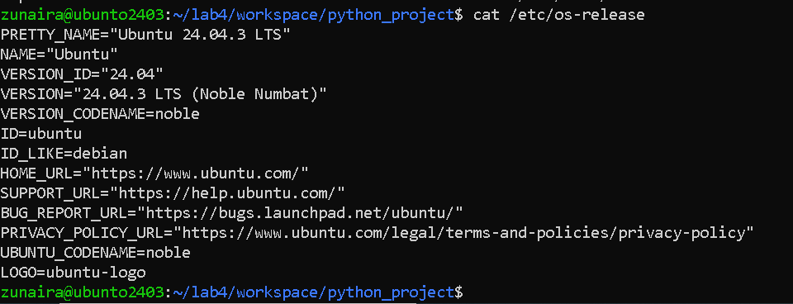
Step6
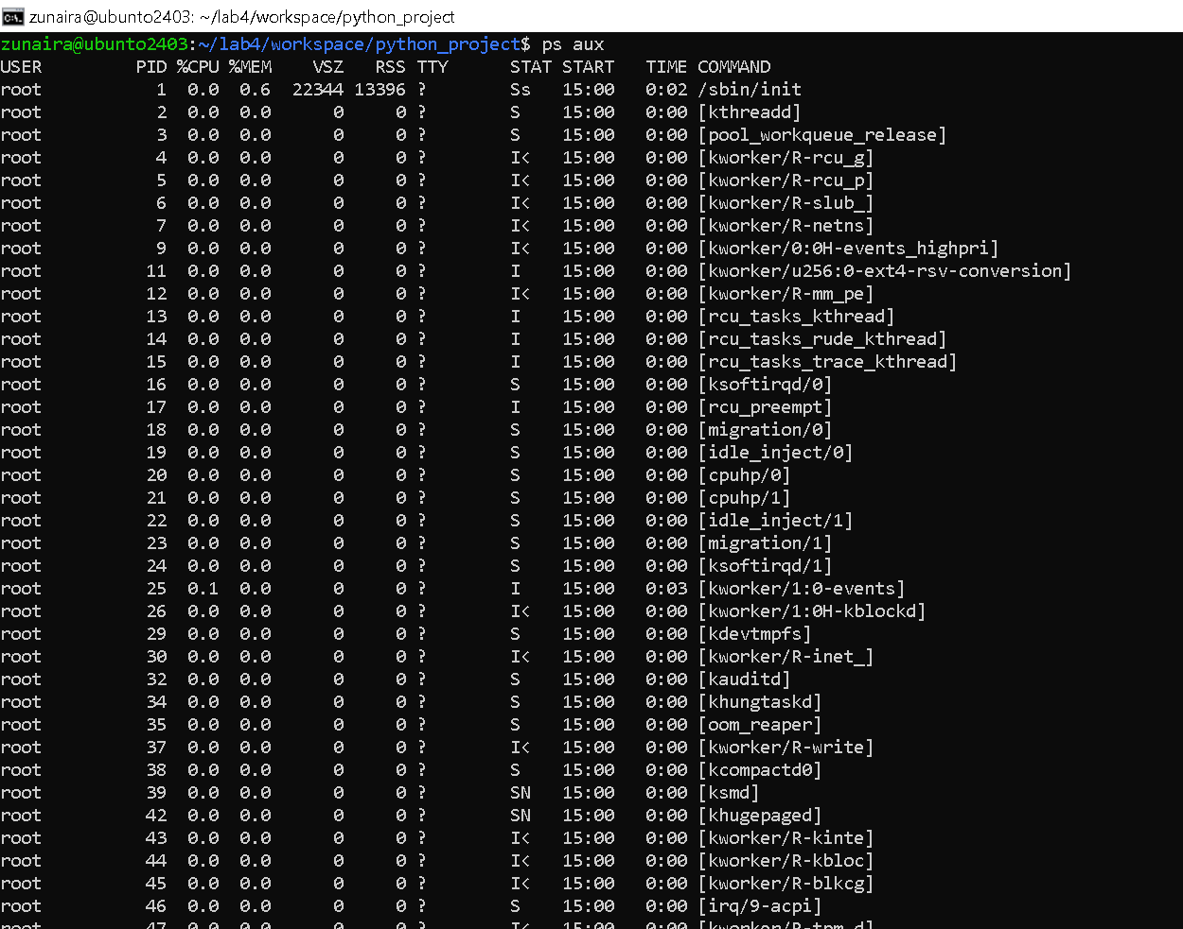
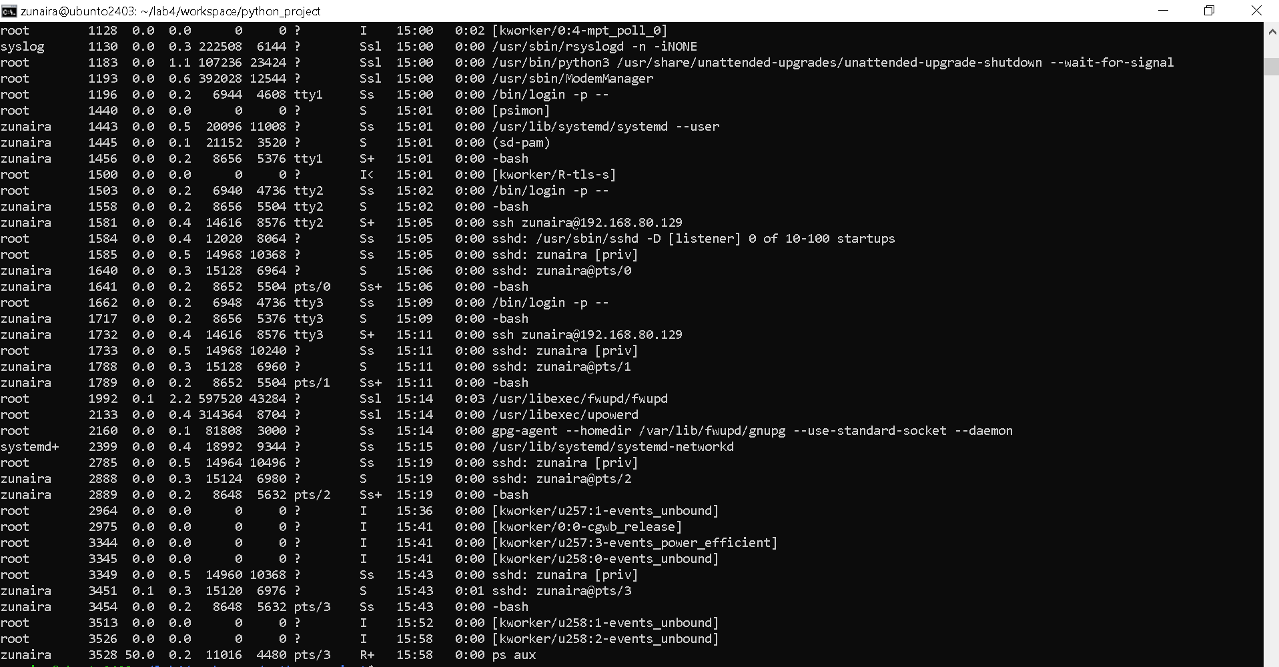
Task 6 – Users and account verification (no sudo group change)

Step1
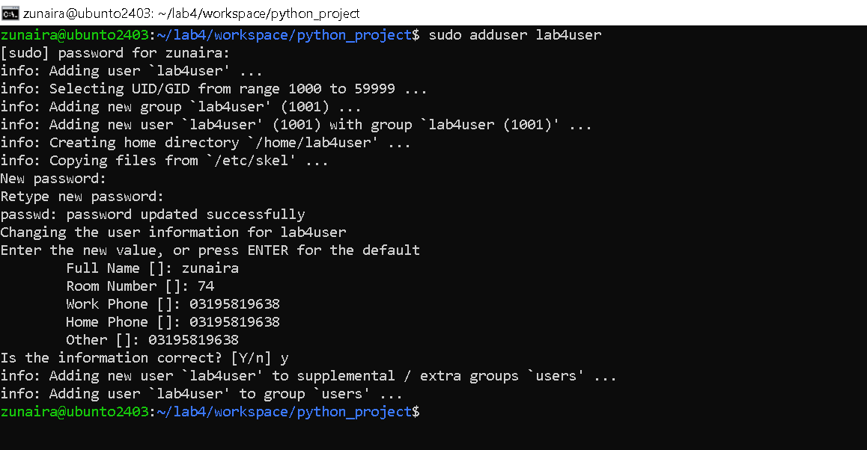
Step2
Step3
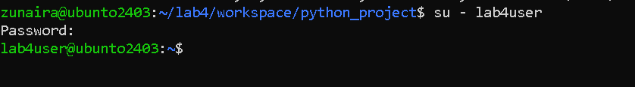
Step4
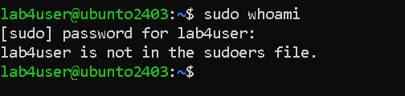
Step5
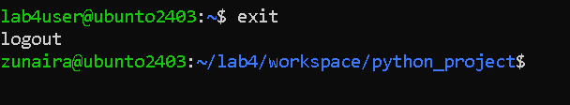
Step6
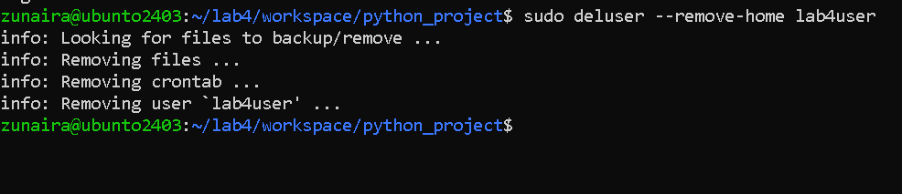
Bonus Task 7 – Create a small demo script using an editor and run it
Step1
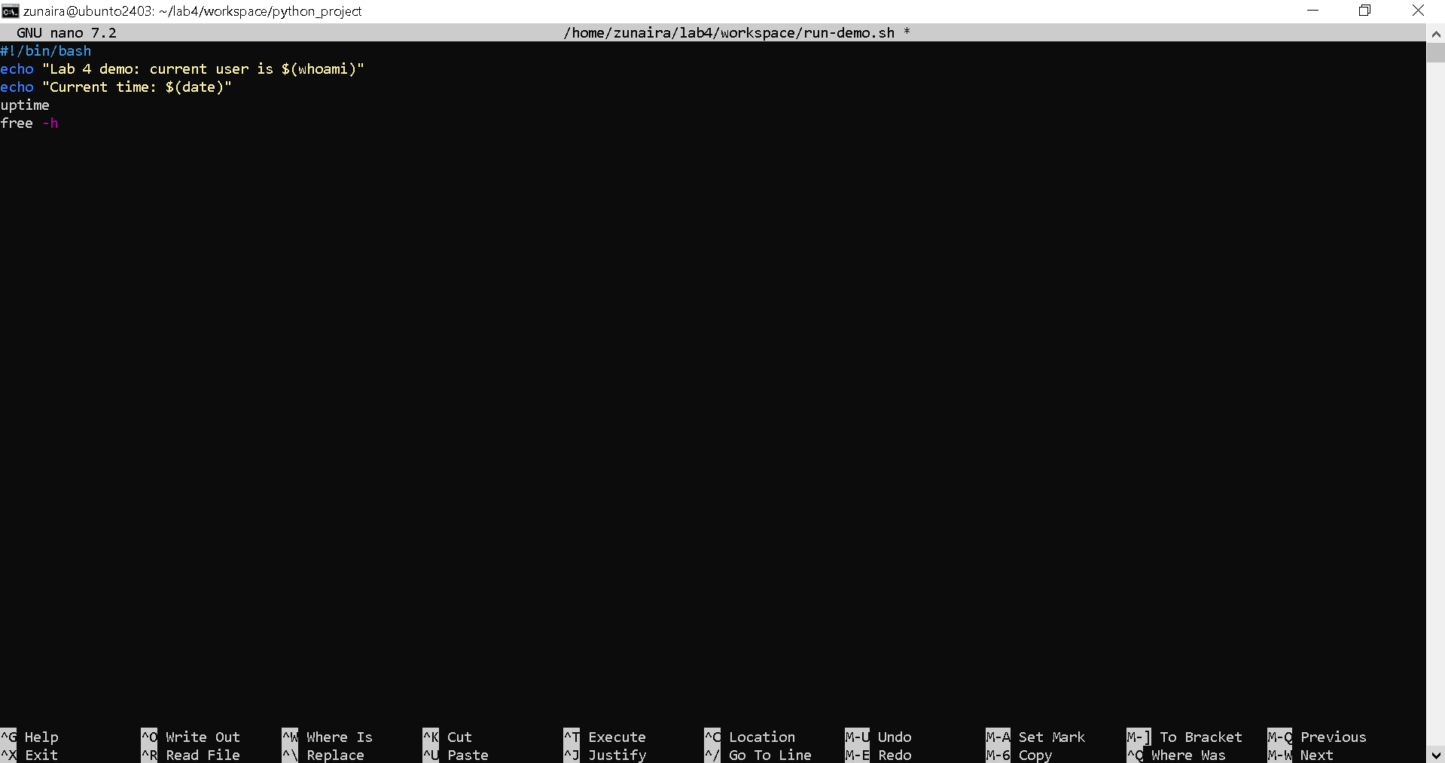
Step2
Step3
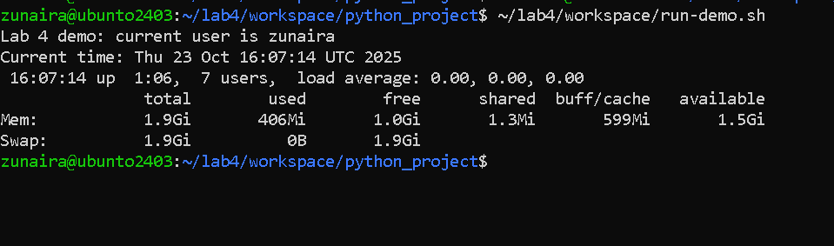
Step4
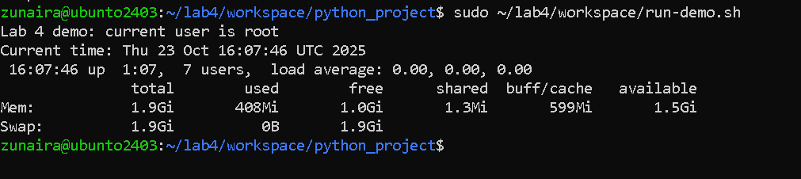
Exam Evaluation Questions
1. Remote Access Verification (Cyber Login Check)
Step1
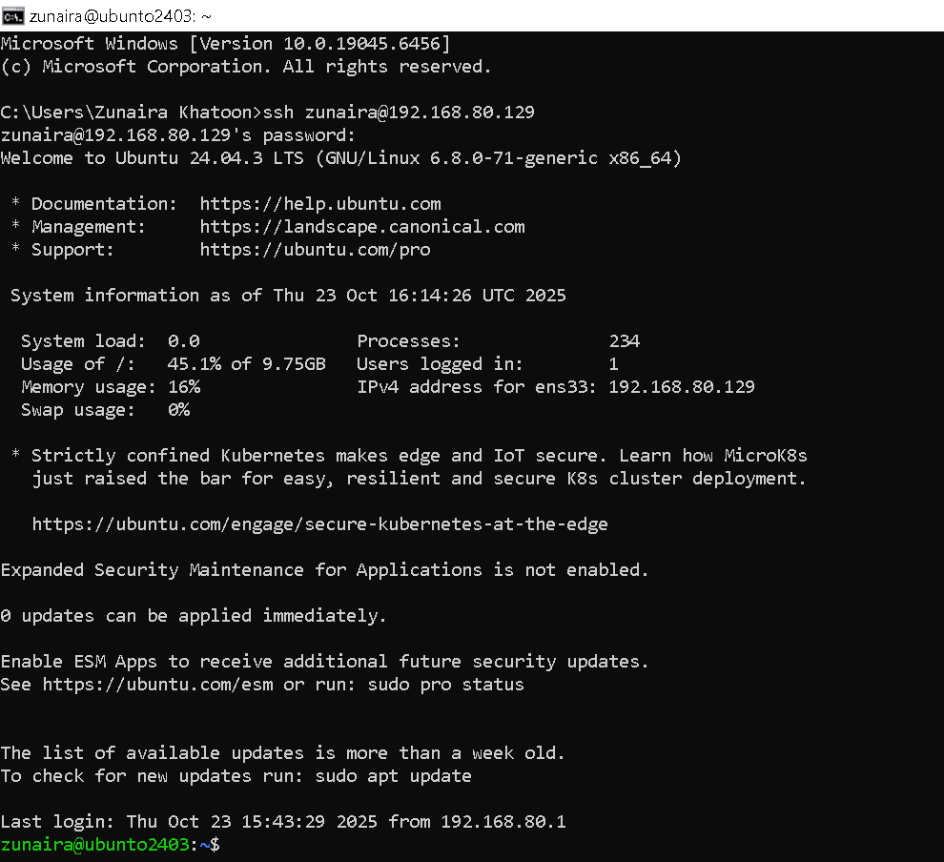
Step2
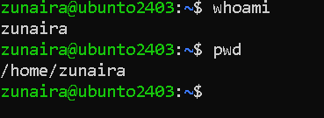
Step3
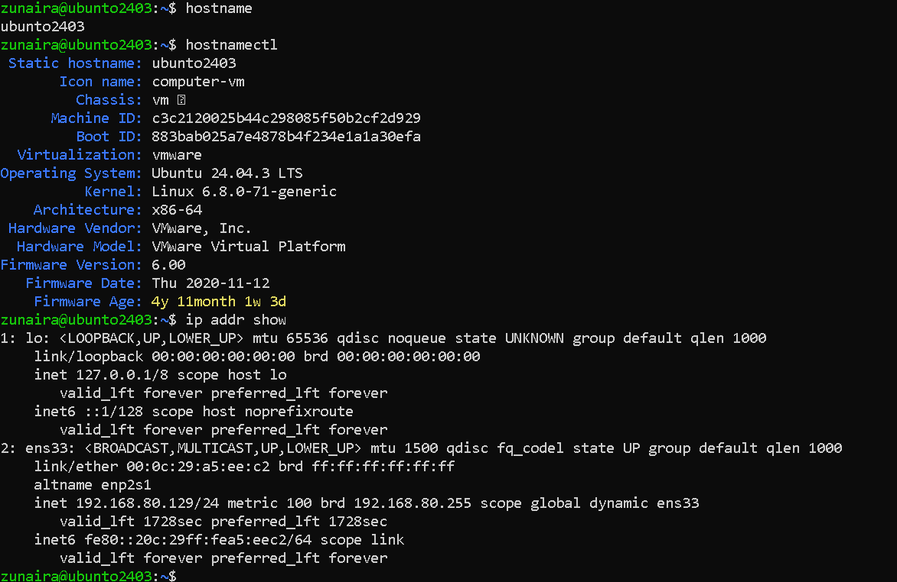
2. Filesystem Inspection for Forensic Evidence
Step1
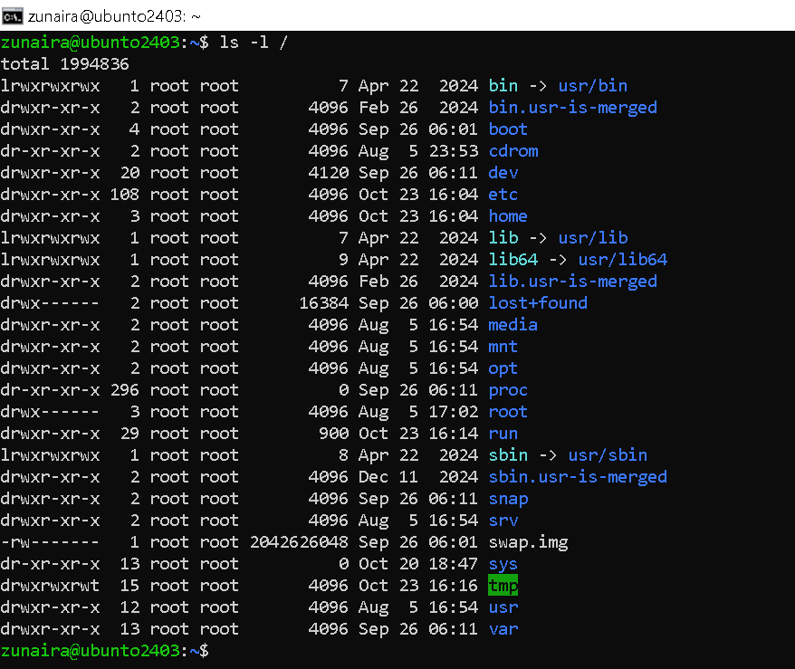
Step2
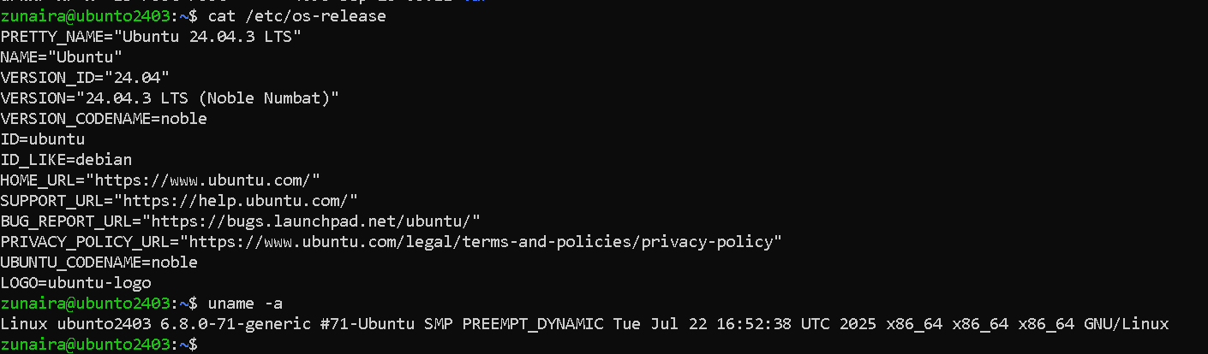
Step3
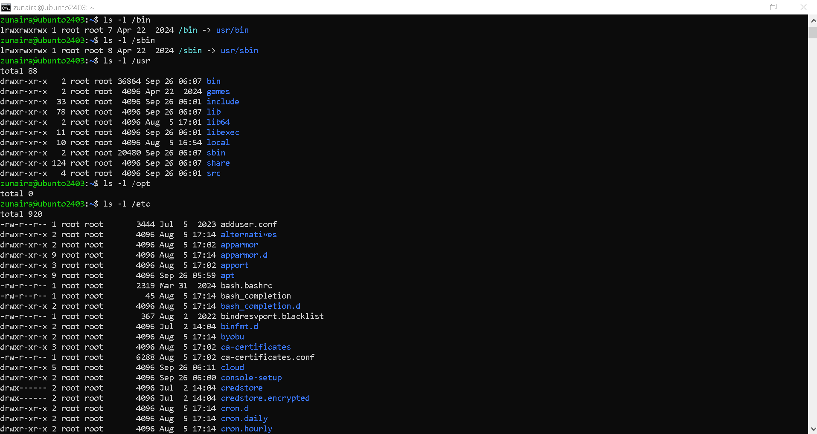
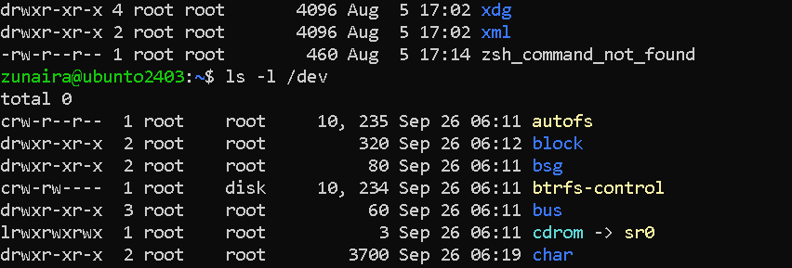
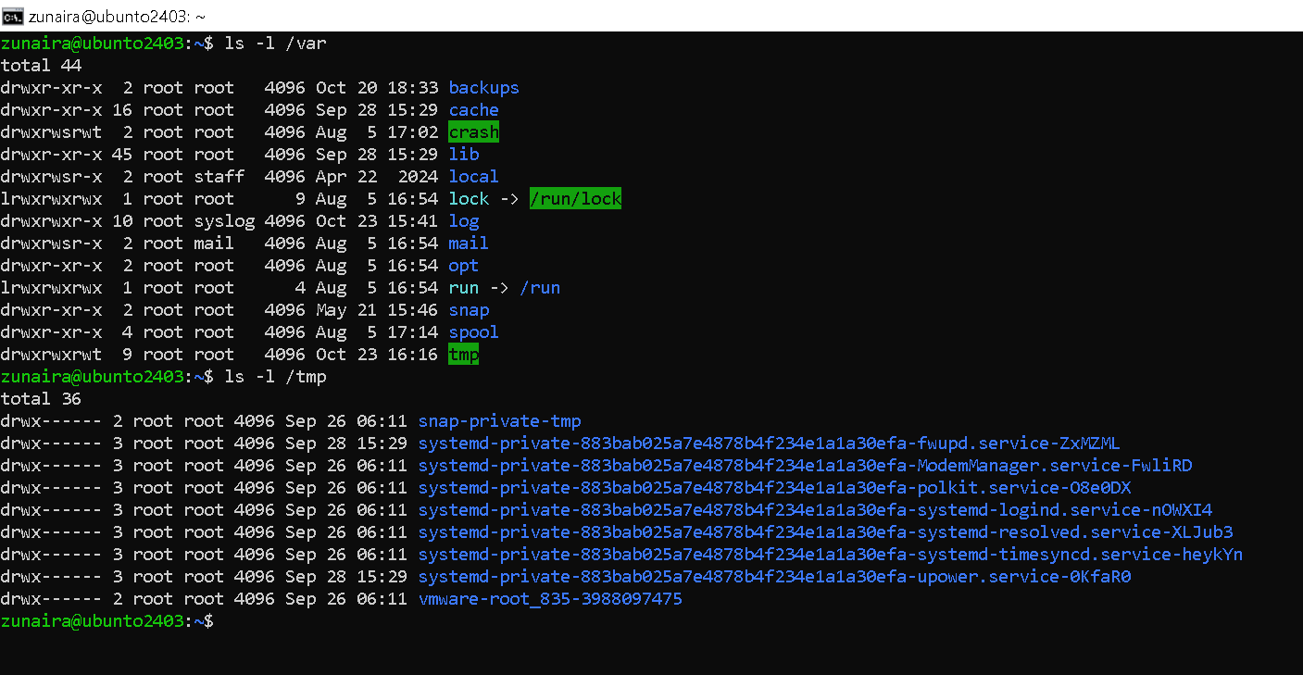
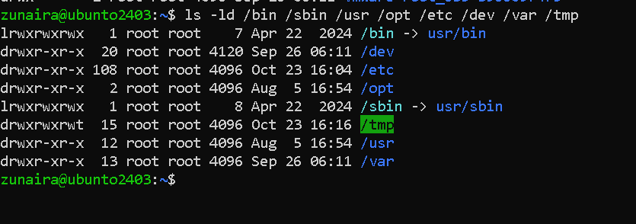
Step4
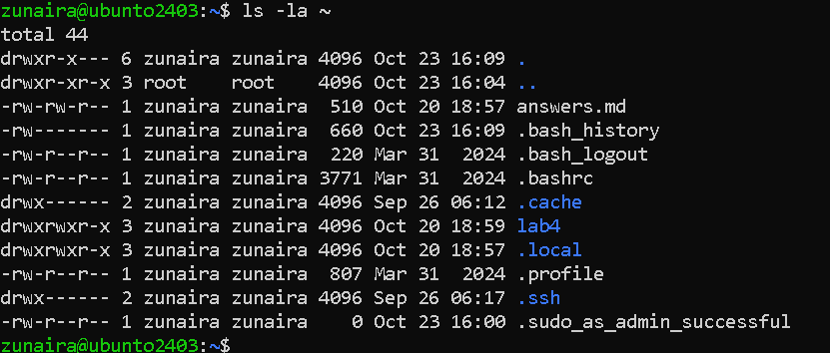
Step5
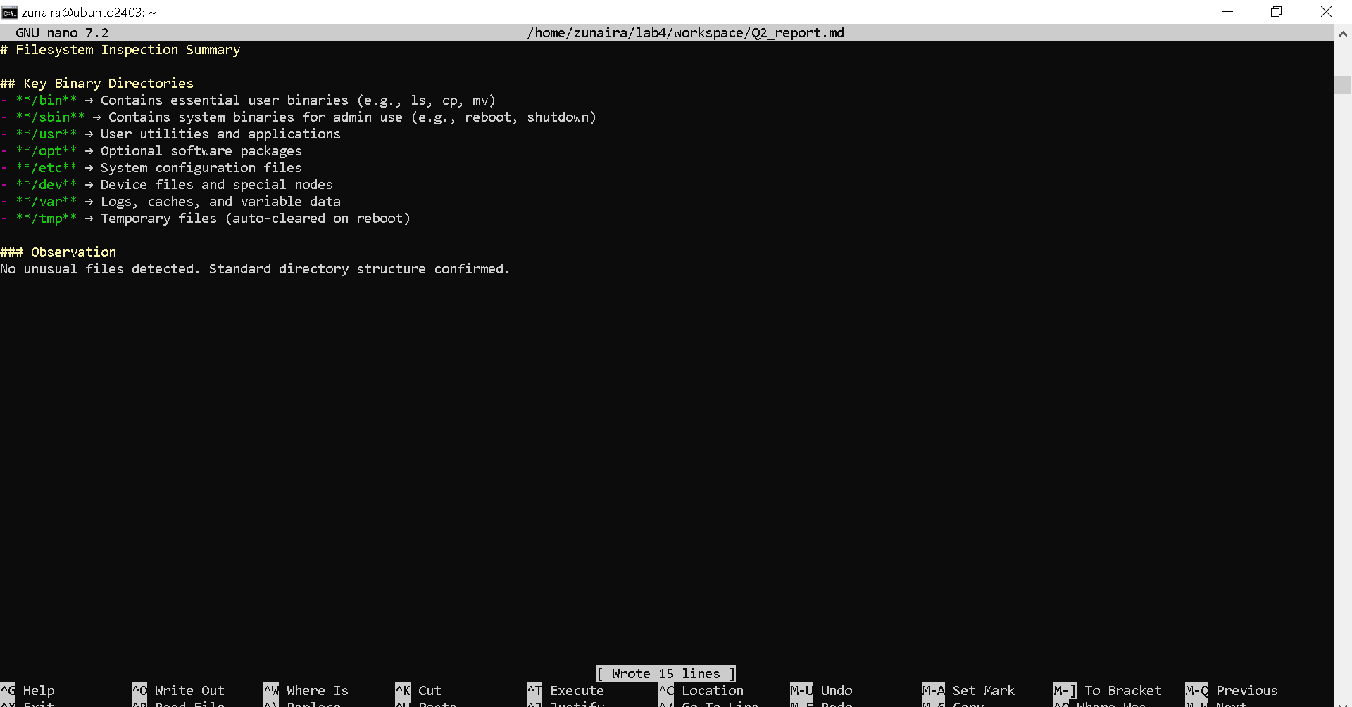
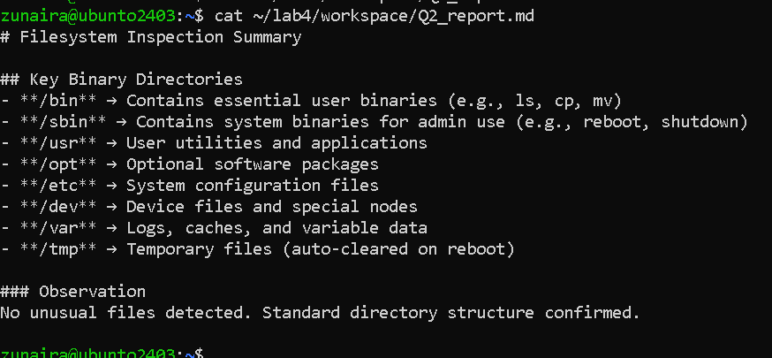
3. Evidence Handling & File Operations
Step1
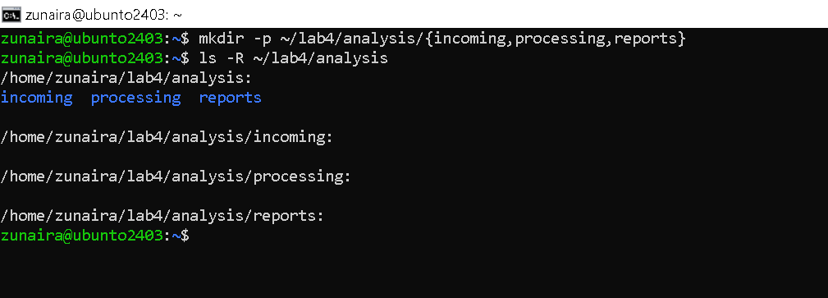
Step2
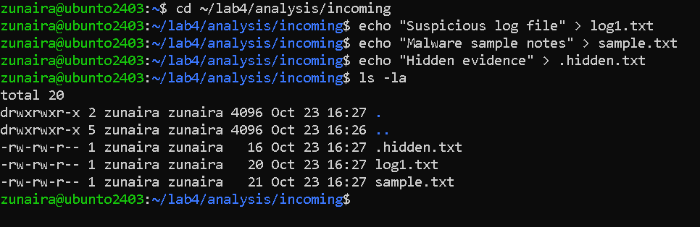
Step3
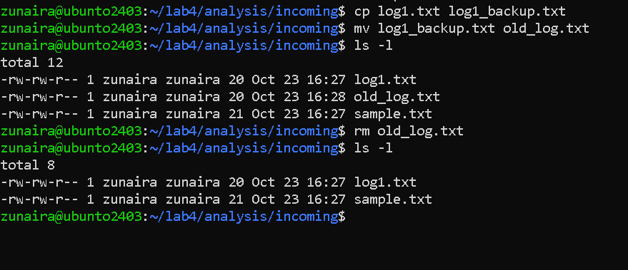
Step4
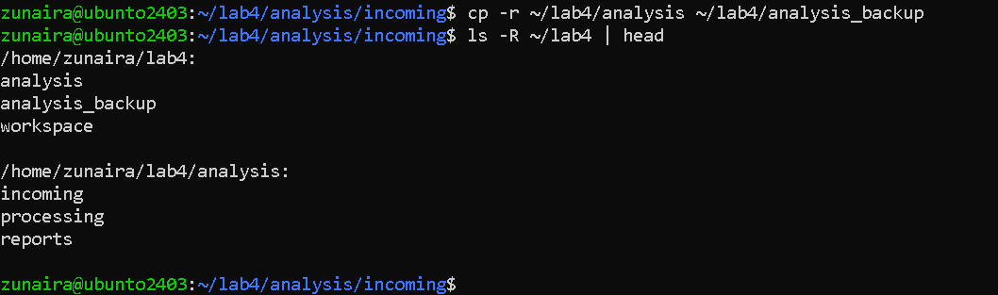
Step5
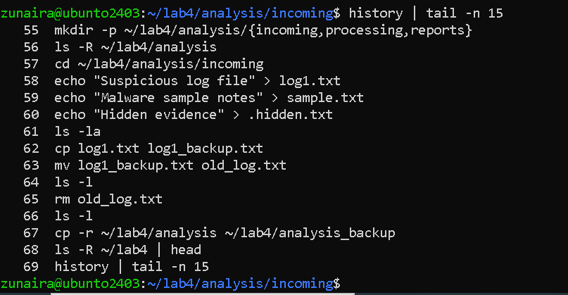
Step6
Q4 — System Profiling and Process Monitoring
Step1
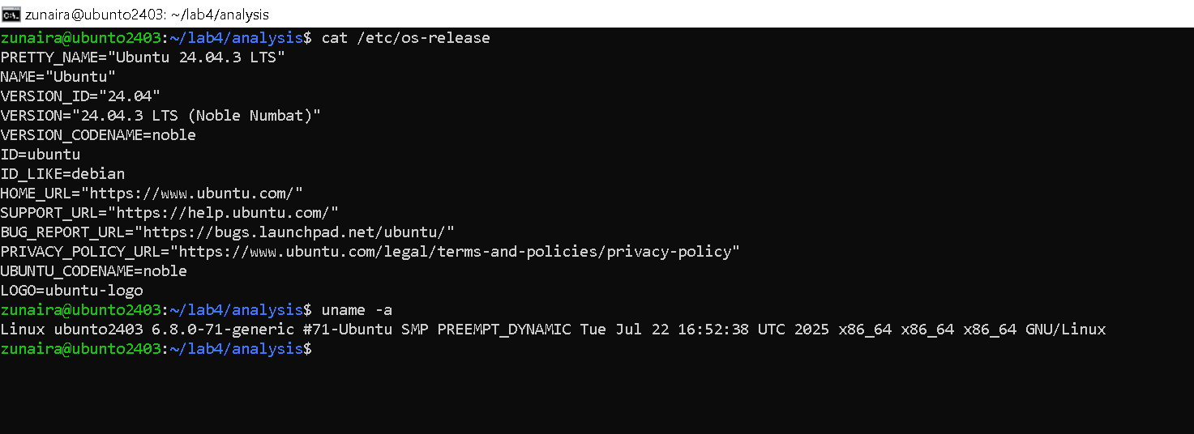
Step2
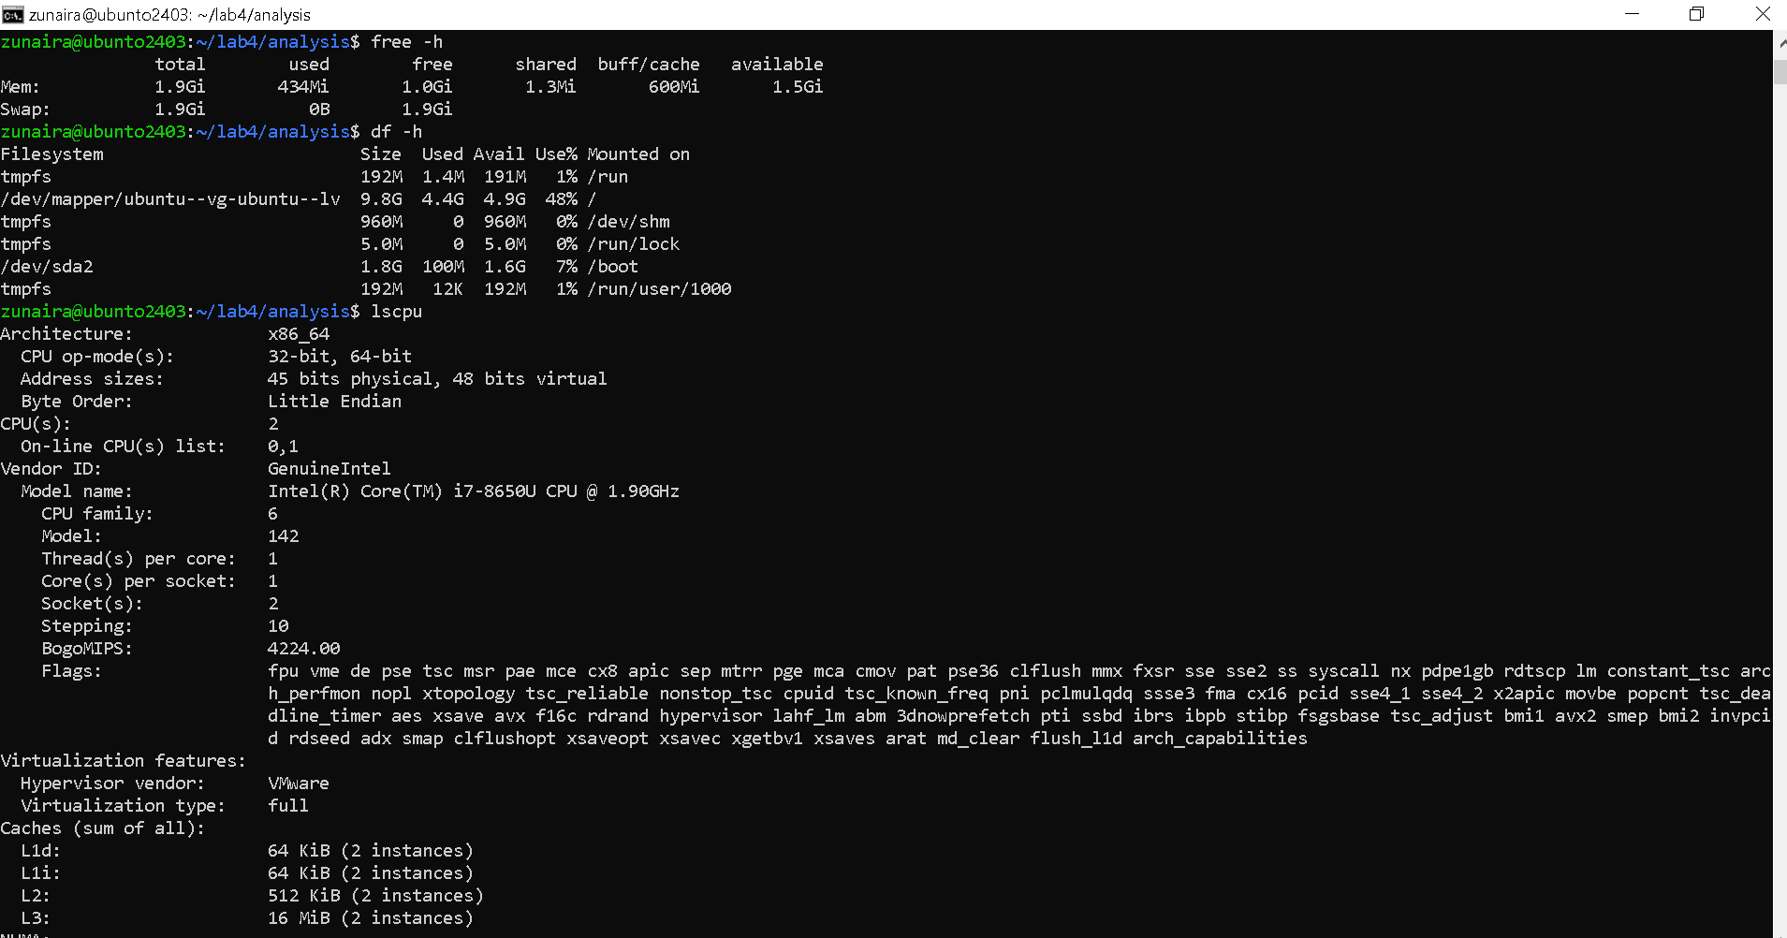
Step3
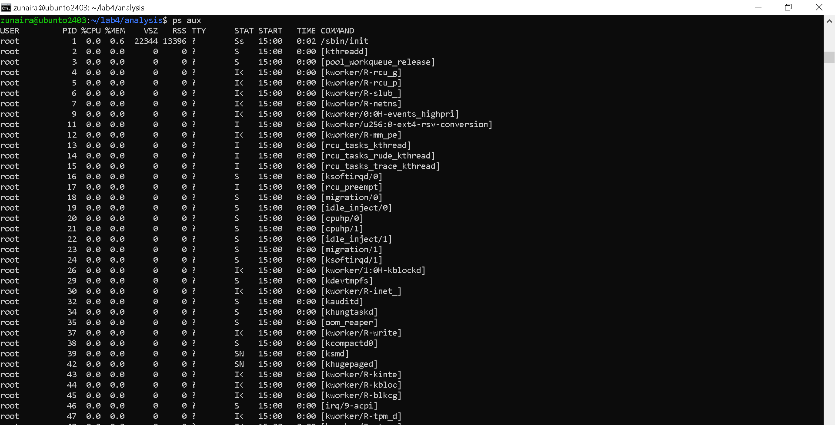
Q5 — User Account Audit & Privilege Escalation Simulation
Step1
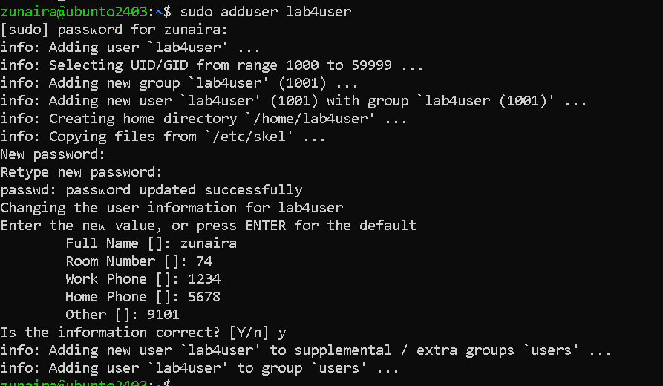
Step2
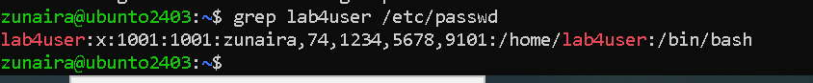
Step3
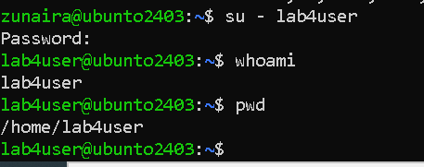
Step4
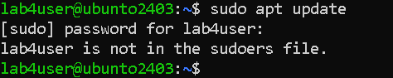
Step5
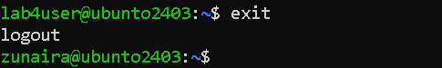
Step6
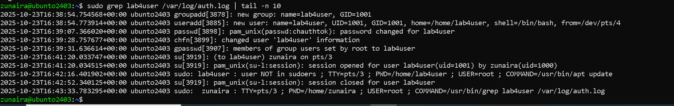
Step7
